**1. What does an empty dictionary's code look like?**

Ans:

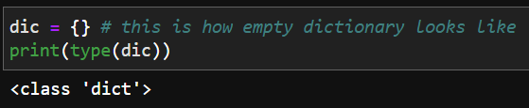

**2. What is the value of a dictionary value with the key 'foo' and the value 42?**

Ans:

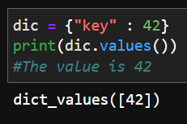

**3. What is the most significant distinction between a dictionary and a list?**

Ans: A list consists of a list of values where as in dictionaries we have a key-value pair.( Also in previous version of python dictionaries were unordered which is not the case now and lists were always ordered)

**4. What happens if you try to access spam['foo'] if spam is {'bar': 100}?**

Ans :

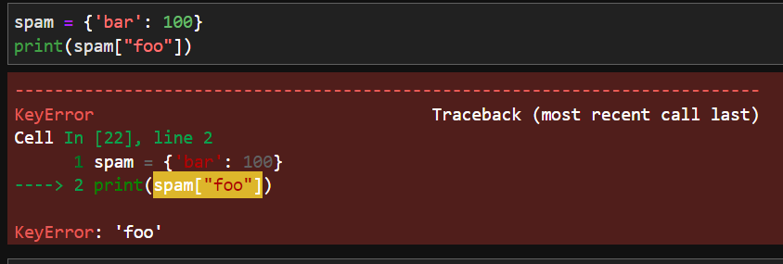

We get a KeyError as the key “foo” cannot be found in the dictionary bar.

**5. If a dictionary is stored in spam, what is the difference between the expressions 'cat' in spam and 'cat' in spam.keys()?**

Ans: No difference as both check whether “cat” is present in the key of the dictionary.

**6. If a dictionary is stored in spam, what is the difference between the expressions 'cat' in spam and 'cat' in spam.values()?**

Ans: 'cat' in spam checks whether 'cat' is present in the keys within the dictionary whereas 'cat' in spam.values() checks whether 'cat' is present in values(of some corresponding key) in dictionary.

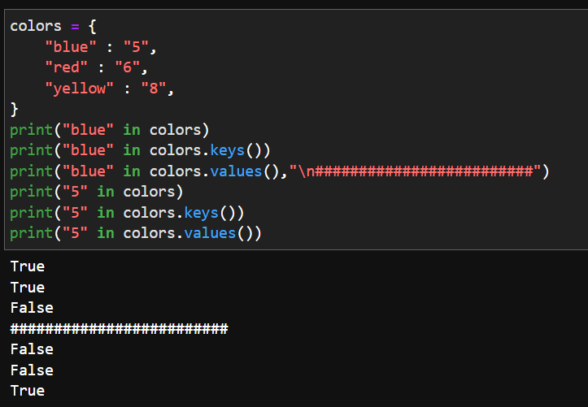

An example of how it works

**7. What is a shortcut for the following code?**

**if 'color' not in spam:**

**spam['color'] = 'black'**

Ans:

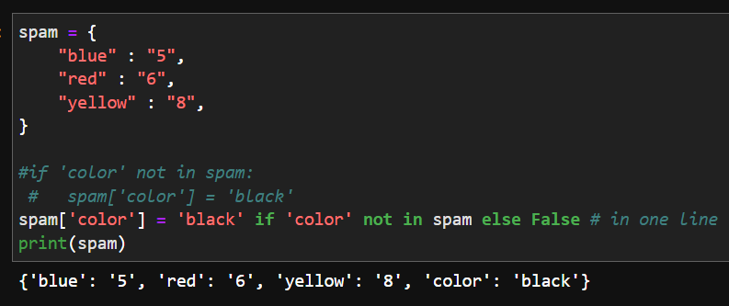

**8. How do you "pretty print" dictionary values using which module and function?**

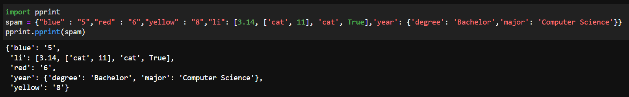

Import pprint and use function pprint()